## Colorado Board of Veterans Affairs Regular Monthly Meeting

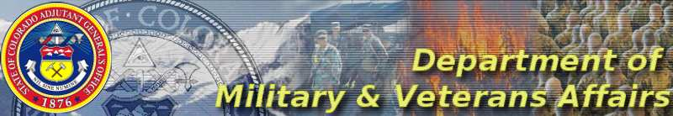

## 

**01 October 2021 at 0900 Hrs**

**Via WebEx**

## AGENDA

* Pledge of Allegiance to the Flag of the United States & Moment of Silence for POWs/MIAs and in support of the troops
* Roll Call of Members and Introduction of Staff & Guests
* Guests should state their Congressional District
* Approval of Minutes: September 2021
* Public Comments (limit three minutes)
* Old Business
  + Bylaws committee: member absences
  + DACOWITS
  + Honor Guards
  + Burlington/Meeting Attendance
* New Business
* Restoration of Honor
* Retiring Member Recognition
* Reports:
* DMVA/Governor’s Office/Legislative – Greg Dorman
* DVA – David Callahan/Joanne Iglesias
* Grants – Gail Hoagland
* VCLCs/Colorado Monument Trust - Robby Robinson
* UVC– Pat Hammon
* Board Member Remarks (limit two minutes)
* Upcoming meetings
  + 05 November Steamboat Springs (annual training 04 November)
  + 03 December VCLC Aurora
* Adjournment