## Colorado Board of Veterans Affairs Regular Monthly Meeting

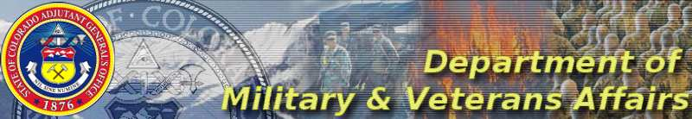

## 

**06 May 2022 at 0900 Hrs**

**VHA VISN 19**

**4100 E. Mississippi Avenue**

**Glendale, CO 80246**

**Virtual Option via WebEx**

## AGENDA

* Pledge of Allegiance to the Flag of the United States & Moment of Silence for POWs/MIAs and in support of the troops
* Roll Call of Members and Introduction of Staff & Guests
* Approval of Minutes: April 2022
* Public Comments (limit three minutes each)
* Old Business
  + HCR 22-1003: Extend Homestead Exemption to Gold Star Spouses
  + Capitol Improvement Committee: Union Soldier Statue Feedback
  + Strategic Plan WIG Committees
* New Business
  + VTF Application Decisions
* Reports:
* DMVA/Governor’s Office/Legislative/DVA – David Callahan
* CCVSOA/NACVSO – Marshall Bosworth
* State Veterans Service Officers – Debra Antista-Bianchi, Kristy Cunningham, Dominic Edginton, Eric Moncibais, Drew Stem
* WROS – Joanne Iglesias
* VMC and Honor Guard Stipend – Angela Ingalls
* Grants – Lisa Stamm
* Board Member Remarks
* Upcoming meetings
  + 06 May – Durango
  + 05 June – Steamoat Springs
* Adjournment