COLORADO DEPARTMENT OF MILITARY AND VETERANS AFFAIRS
VETERANS TRUST FUND GRANT
APPLICATION INSTRUCTIONS
Applications due: March 01, 2022
PROGRAM SUMMARY
The Veteran’s Trust Fund (VTF) grant was established in 2000 by the State General Assembly to address the needs of veterans in the state of Colorado. The VTF is funded through Tobacco Master Settlement funds. According to statute, the VTF receives an annual Long Bill appropriation funded by this settlement revenue.

Section 28-5-709, C.R.S., requires VTF monies to be used for capital improvements or needed amenities for state veterans nursing homes, costs incurred by state veteran cemeteries, costs incurred by the Division of Veterans Affairs to administer the program, and grants to veteran programs operated by nonprofit veterans organizations that meet criteria adopted by the Colorado Board of Veterans Affairs and selected by that Board as grant recipients. Nonprofit organizations eligible to receive funds must be nationally recognized veterans service organizations typically operating as a 501(c) 19 or 501(c) 23. Some organizations with a 501(c) 4 designation are eligible if so recognized. Eligible entities must serve Colorado veterans.

The grant is governed by the Colorado Board of Veterans Affairs (Board) and the Colorado Division of Veterans Affairs (Division). The Board is comprised of seven members appointed by the governor and is responsible for oversight of the VTF grant program. The Statute establishes the Board’s authority over the VTF and directs the Board to require applicants to submit an application in a form adopted by the Board and to vote on each request for funds. A majority vote is sufficient to approve a grant. The Board approves guidelines and standards including the form of application, criteria for identifying qualified applicants, criteria for selecting appropriate grantees, the amounts of grants awarded, and standards for determining the effectiveness of veterans programs that receive a VTF grant.

The Division is responsible for implementing and administering the program within the statutory requirements and Board guidelines. Administration activities include processing applications, assisting the Board with grant decisions, and providing management and oversight of all awarded grants.

PURPOSE AND SCOPE
The overarching goal of the Veterans Trust Fund is to support organizations in meeting community defined needs of veterans in the State of Colorado. The scope of program services includes direct assistance to veterans to address the material or financial unmet needs of veterans. A clear need must be present. The expected outcomes/impacts include enhanced self-sufficiency and economic stability, increased access to healthcare, stable housing and supportive services, increased food security, enhanced relationships and overall well-being.

2022-2023 VTF Application Instructions p1
REQUIREMENTS
Eligible Organizations
Nonprofit organizations nationally recognized by the U. S. Congress as an organization that provides services to veterans, typically with a designation by the Internal Revenue Service as a 501(c) 19 or a 501(c) 23. Some 501(c) 4 organizations with a designation may be eligible as well.

Programs and projects
Eligible programs and projects to apply for funds are those located in Colorado that provide direct assistance to meet the needs of Colorado veterans. Veterans whose character of service is other than Dishonorable are eligible for services under this program.

Terms and limitations
An organization may apply for only one grant per funding cycle. An organization may not receive funding from both the Veterans Assistance Grant (VAG) and VTF grant programs. Administrative or capital costs are not allowed, except as noted in statute for Veterans Community Living Centers. Memorials, club renovations, honor guards, and tributes to veterans are not included in the VTF grant program. Applicant organizations must directly provide services; services provided only via pass-through funding are not permitted. Grant funds cannot be used to supplant current funding of existing activities. “Supplanting” is defined as replacing existing funds of a program or project with funds from this grant program. Grant funds may only be used to address a material or financial unmet need of a veteran. Other use of funds is prohibited. For vehicle purchases, contact the Grant Administrator for other terms and limitations that may apply. A current bid sheet is required for any vehicle purchase.

Applications
Only one application per organization will be considered. Original, signed applications (NOT electronic signatures) must be received by 3:00pm March 1, 2022. ONLY electronic submissions will be accepted. You are encouraged to set up receipt confirmation on your email. Applications MUST be submitted to: VTF.Application@dmva.state.co.us Applications submitted via mail will NOT be accepted. All of the required elements must be included in the submission. Applications must be complete and in compliance at the time of submission. Incomplete applications will not be considered. Required elements are:
- Application Form
- Program Detail Form
- Budget that includes a Budget Narrative
- Pre-Award Questionnaire
- Proof of current and valid Nonprofit Status (IRS and current affirmation letter from National or State organization)
- Current Certificate of Good Standing with Secretary of State
- Current IRS form W-9
Applications materials should be submitted as two (2) attachments. Please see details for each attachment.

Questions may be referred to the Grant Administrator by phone at 720-628-1480 or by emailing gail.hoagland@dmva.state.co.us.
2022-2023 VTF Application Instructions p2
Application Evaluation Criteria
Applications will be evaluated based upon the following criteria: need for the service provided, local partnerships and collaboration, number of veterans projected to be served, expected outcomes and proposed measures of effectiveness, and historical information on program effectiveness. Refer to the sections on Application and Evaluation for details.

Only complete applications received by the deadline of March 1, 2022 will be considered. Email to: VTF.Application@dmva.state.co.us Mail delivery or Hand delivery is not possible at this time. Ensuring that applications are received by the grants office by the deadline is the responsibility of the applicant.
The required forms for 2022-2023 VTF Grant are attached. Where forms are not required follow the format specification
- 2022-2023 VTF Grant Application Form (2 page form attached)
  - Submit original copy of the entire grant application form
  - Must include an original wet signature of the authorized representative

- Program Details (form attached)
- Complete the required form that accompanies the application document
- Handwritten forms are not accepted
c. Respond to each question with complete sentences and paragraphs that fully address the element
d. Program budget:
    - A complete line item budget with detailed budget narrative (example attached)
    - Identify other sources of funding that will be used for the program or project
Submit all items in I. and II. as one attachment labeled Attachment 1
III. Appendix Documents
Attachments Pre-Award Questionnaire (form attached)
Proof of Current (within last 5 years) Nonprofit Status (If status is through the State or National entity, also submit a current letter of affirmation from that entity.)
Proof of current Certificate of Good Standing with the Colorado Secretary of State
Completed and current IRS W9 Form with EIN number
Submit all Appendix documents as one attachment labeled Attachment 2.
Do not submit any other documents.

2022-2023 VTF Application Instructions p3
EVALUATION
Initial screening of each application is performed by the Division’s grant administrator to assess both eligibility and completeness. Ineligible and incomplete applications will be rejected. Those that are eligible and complete will proceed to the evaluation process. Applications are evaluated by a subcommittee of the Colorado Board of Veterans Affairs and the director or designee of the Colorado Division of Veterans Affairs in conjunction with the DMVA grant administrator. The Board subcommittee is comprised of board members appointed by the chair. The subcommittee makes recommendations utilizing an objective scoring tool and considering both the monies available to allocate and geographic distribution factors. Those recommendations are forwarded to the full Board for consideration and final vote. Scoring considerations are as follows:

- Need – considers the extent to which the applicant:
- establishes the need for the specific services to be delivered through a discussion of the estimated numbers of veterans in the proposed target area defined. The data source is clearly identified. The target area is clearly identified. (20 points)
- identifies the projected number of unduplicated veterans to be served which correlates with the number of veterans in the target area, the level of services to be delivered and the program budget (10 points)
- identifies the existing service gaps, and addresses duplication of services by other providers within the target service area (5 points)
- geographic distribution as determined through mapping of ALL applications to ensure the broadest possible coverage of the state and to identify and avoid duplicate services in any given region or area of the state (5 points)

- Local partnerships – considers the extent to which the applicant:
- Describes partnerships and collaborative approaches with CVSO and other organizations to establish
linkages for services (10 Points)

- Outcomes and effectiveness – considers the extent to which the applicant:
- clearly identifies expected outcomes (expected changes or impacts) of services as well as measurable outputs (number to be served) (15 Points)

- Historical information on program effectiveness – considers the extent to which the applicant:
- Identifies the number of veterans previously served and provides qualitative information regarding the program’s effectiveness in achieving identified outcomes (15 Points)
- For previous grantees: considers the administrative performance on the grant including timeliness, achievement, and compliance (10 Points) or
- For new applicants: considers the capability to provide the services identified and demonstrates a history of like services offered to veterans (10 Points)

- Budget appropriateness – considers whether the budget request is reasonable, allowable, and appropriate for the services to be delivered, the outcomes expected and the number of veterans to be served (10 Points)

Available funds –The Board will consider total funds available, total funds requested, the number of applications, the geographic distribution of applicants, and the number and types of programs in region.

Applications scoring less than 60 points will not be considered. The full Board conducts application review, votes, and awards grant recipients. The Board’s decisions are final.
2022-2023 VTF Application Instructions p4
GRANT AWARDS
Applications may be funded in full or part. Funding thresholds may be established based upon the following factors: Risk Assessment, Previous Compliance or Utilization of Grant Funds, Track Record and Capacity for New Grantees, and availability of funds. A Letter of Intent and grant agreements will specify any limitations placed on partial funding.

When an award has been granted the grantee organization will receive a letter of instruction and a Grant Agreement. The Grant Agreement is a unilateral agreement. By signing and submitting an application, the applicant agrees to accept the terms and conditions if awarded. The Grant Agreement document finalizes that agreement with specific terms. Expenses are not eligible for reimbursement until the date that the agreement is fully executed or 01 July, whichever is later.

The grantee will receive a handbook that contains of explanation of VTF grant processes and procedures. The authorized representative, program contact and other involved individuals will be required to attend a grantee webinar training at the beginning of the grant period. Attendance is MANDATORY and funds will be frozen if the webinar is not attended.

Funds will be reimbursed when grantees have expended organizational funds for grant purposes. In most cases the grantee will utilize organizational funds and request reimbursement of those funds from the department after providing acceptable proof of expenditures. Grantees must submit back-up documentation for expenditures such as a copy of the check and corresponding invoice, bill or receipt. Reimbursements lacking proper back-up documentation will be denied.

In the event the organization does not have sufficient organizational funds, an advance of funds may be requested. The authorized representative must submit a written request that clearly justifies the need for advance payment. Advance funds must be fully accounted for within 90 days.

Advance payments may not exceed $10,000 or 25% of the total grant award, whichever is less. An exception is established for vehicle purchases: a grantee may receive a 100% advance to purchase a vehicle. Any other unique advance requests exceeding the specified limit (such as for stand downs) must be fully justified and approved by the Grant Administrator and the Controller.

Performance Progress Report Forms will be included in the agreement package. Regardless of the date the grant is awarded and funds dispersed, quarterly reports are due to the Department on October 15; January 15; April 15, July 15 and a final cumulative report on July 15. Reports must include number of veterans served, number of unduplicated veterans served, the number of contacts of services, average service contacts per individual, services provided, how they were served, measures of effectiveness, satisfaction survey data, accomplishments and successes, and an accounting of all expenditures made during the reporting period.

By June 15, any advanced funds not expended and accounted for must be returned by the grantee to the Department. Advance funds will not be provided after 20 May. Any final requests for reimbursement of expenses must be received by the Department by June 20 of the grant contract period.

2022-2023 VTF Application Instructions p5
DEPARTMENT OF MILITARY AND DEPARTMENT OF MILITARY AND VETERANS AFFAIRS
Division of Veterans Affairs
6848 S. Revere Parkway
Centennial, Colorado 80112
Phone (720) 628-1480

2022-2023 GRANT APPLICATION
The Grant Application and Program Detail Forms are required and are available separate from these instructions.
Please visit www.colorado.gov/pacific/vets, email gail.hoagland@dmva.state.co.us or call 720-628-1480.

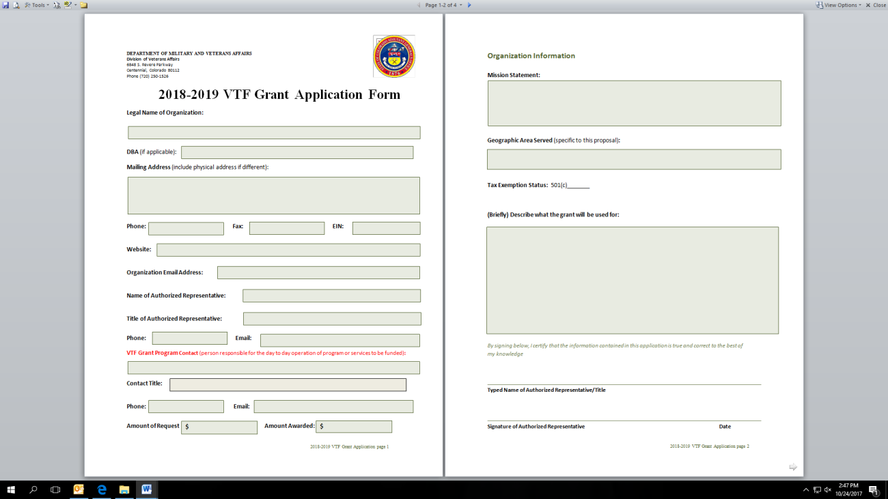
.

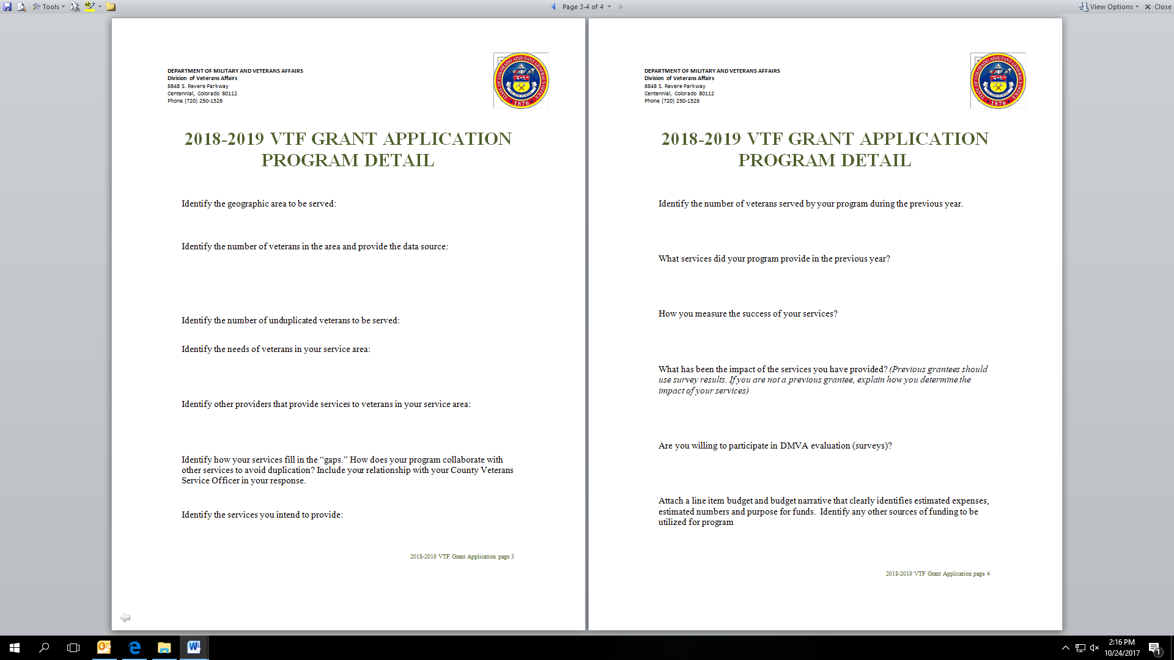

2022-2023 VTF Application Instructions p6
DEPARTMENT OF MILITARY AND VETERANS AFFAIRS
Division of Veterans Affairs
6848 S. Revere Parkway
Centennial, Colorado 80112
Phone (720) 628-1480

2022-2023 VTF GRANT
BUDGET EXAMPLE

Budget and Budget Narrative
For
XYZ Organization

TOTAL
Rent/Housing Assistance 20 Veterans @ $1,000/each $20,000 Assistance to veterans to remain housed and prevent homelessness
EXAMPLE ONLY
Second request results in referral to Financial/Budgeting Program

Utility Assistance 30 Veterans @ $100/each $ 3,000
Assistance to veterans to pay arrears for gas and electric services,
or purchase of propane or firewood. Veteran referred to LEAP.
Second request results in another referral to LEAP and to Financial/Budgeting Program

Food/Gas cards 20 Veterans @ $50/each $ 1,000
Purchase of food or gas cards for critical assistance
Second requests result in referrals to Financial/Budgeting Program

Medical/Dental 10 Veterans @ $1,000/each $10,000
Provide assistance for non-VA related or eligible medical or dental health services
Veterans encouraged to sign up for VA Health or other insurance options

Emergency Assistance 30 Veterans @ $150/each $ 4,500
EXAMPLE ONLY
Provide assistance for situations/needs that are unanticipated

Total Request $38,500

2022-2023 VTF Application Instructions p7

DEPARTMENT OF MILITARY AND VETERANS AFFAIRS
Division of Veterans Affairs
6848 S. Revere Parkway
Centennial, Colorado 80112
Phone (720) 628-1480

2022-2023 VTF APPLICATION ATTACHMENTS
Include each appendix attachment and provide in the order listed

      - Pre-Award Risk Assessment Questionnaire

      - Proof of federal tax-exempt status
Also called a Letter of Determination or a Letter of Affirmation. This letter must be dated within the last five years. For some, you must submit the Letter of Determination/Affirmation AND an affirmation letter from the State or National entity.
      - Certificate of Good Standing with Secretary of State
Include current certificate

      - Current IRS W-9
Also called Request for Taxpayer Identification Number and Certification. This must be signed and dated.

2022-2023 VTF Application Instructions p8
DEPARTMENT OF MILITARY AND VETERANS AFFAIRS
Division of Veterans Affairs
6848 S. Revere Parkway
Centennial, Colorado 80112
Phone (720) 628-1480

2022-2023 VTF APPLICATION CHECKLIST
DO NOT SUBMIT this checklist as part of your Application
The Veterans Trust Fund Grant application consists of the following components, which should be submitted in the order listed below. This checklist is provided to help ensure a complete proposal. This checklist should not be submitted with the proposal.

Attachment 1:

2022-2023 VTF Grant Application Form (two pages)

Program Detail (form)

Budget: Line item budget and narrative

Other sources of funding that support the program or project

Attachment 2:

Pre-Award Questionnaire

Proof of IRS federal tax-exempt status and/or letter of affirmation, dated within the last five years

Current Certificate of Good Standing with Secretary of State

Current IRS W-9 with EIN (must be signed and dated)

Thank you for your time and effort in completing this application

2022-2023 VTF Application Instructions p9

